 | 35.4 Addon - Power User Tools
Table of content
Bforartists Power User Tools 1
Preferences 2
Animation Toggles 2
Insert/Remove Frames Operators Toggle 2
Operators 2
Location of operators 3
Animation Toolshelf Operators Toggle 3
Operators 3
Location of operators 3
Animation Operators 3
Insert Frame Left 3
Remove Frame Left 3
Insert Frame Right 4
Remove Frame Right 4
Use 4
1. Activate the addon 4
2. Customize which operators you would need 4

Power User Tools
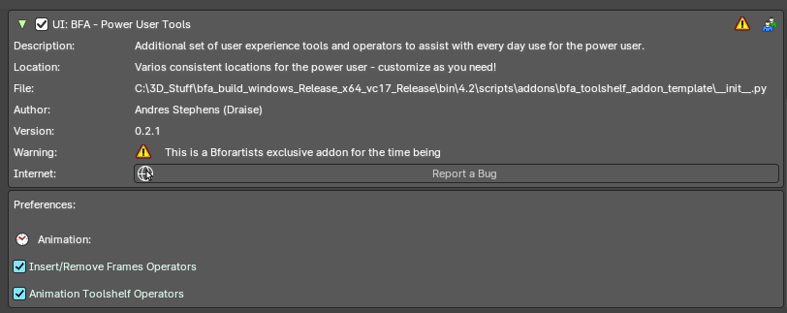
This addon is optional and deactivated by default.
This is an addon with an additional set of user experience tools and operators to assist every day use.
This addon is thanks to Andres Stephens (Draise).

Note
To activate/deactivate an addon, go to Edit – Preferences – Addons tab – and untick any activated addons.
If you’d like to keep your addons for future use, you can either save the preferences, or activate them on demand per workspace in the workspace settings in the property shelf.

Preferences
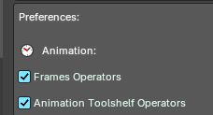
In the addon preferences, you can toggle which group of operators or user experience customization to help assist your needs.

Animation Toggles
These are operators to assist and improve the animation user experience.

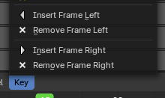
Frames Operators Toggle
Toggle to add operators to insert/remove a frame to the left or right of the timeline cursor. Useful for grease pencil and stop motion animation.

Operators
- Insert Frame Left
- Remove Frame Left
- Insert Frame Right
- Remove Frame Right

Location of operators
3D View Editor – Object Header Menu – Animation Sub-Menu
3D View Editor – Toolshelf – Animation Tab – Animation Panel
Timeline Editor – Key Header Menu
Dopesheet Editor – Key Header Menu
Graph Editor – Key Header Menu
3D View Header – Grease Pencil – Edit mode - Grease Pencil Header menu – Animation sub-menu.
3D View Header – Grease Pencil – Draw mode - Draw Header menu – Animation sub-menu.
3D View Header – Grease Pencil – Edit mode - Animation Panel
3D View Header – Grease Pencil – Draw mode - Animation Panel
3D View Header – Grease Pencil – Sculpt mode - Animation Panel
3D View Header – Grease Pencil – Vertex mode - Animation Panel

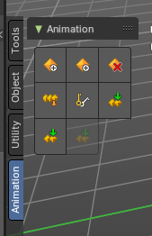
Animation Toolshelf Operators Toggle
Toggle to Adds the animation operators from the header to the toolshelf. Useful for general animation keyframe use from the 3D View.

Operators
For more information of these operators, please visit the chapter Editors - 3D Viewport - Header - Object menu
You can alternatively view these operators in the 3D View Header – Object/Pose Header menu – Animation sub-menu.

Location of operators
3D View Editor – Toolshelf – Animation Tab – Animation Panel
3D View Header – Object/Pose Header menu – Animation sub-menu.
3D View Header – Object/Pose Header menu – Animation sub-menu.

Animation Operators

Insert Frame Left
Inserts an empty frame and nudges all frames to the left of the time cursor. Useful for grease pencil and stop motion animation.

Remove Frame Left
Removes a frame on the right of the timeline cursor and nudges all frames towards the timeline cursor.
Note: Current frame on timeline cursor will be removed.

Insert Frame Right
Inserts an empty frame and nudges all frames to the right of the time cursor Useful for grease pencil and stop motion animation.

Remove Frame Right
Removes a frame on the right of the timeline cursor and nudges all frames towards the timeline cursor.
Note: Current frame on timeline cursor will be removed.

Use

1. Activate the addon
In the user preferences Addons tab, search for “Power User” and activate the addon.
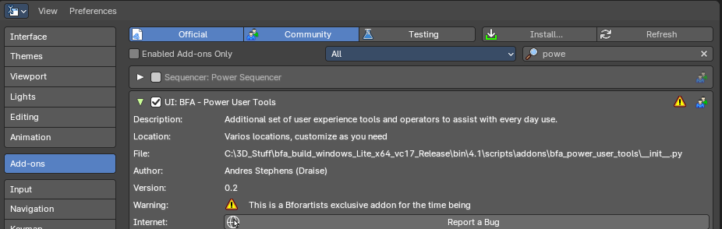

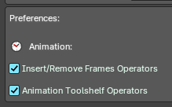
2. Customize which operators you would need
Here you will find categories and groups of operators. Mouse over which group of operators to see the tooltip to learn more.

